SORA (www.soraapp.com)
Sora is a reading app that allows K-12 students to borrow ebooks and audiobooks from their school’s digital collection as well as from the public library collection. After signing up and linking their public library card, students will have access to thousands of ebooks and audiobooks!

Directions to Setup Acccount:
Go to the web address: www.soraapp.com
Video Instructions
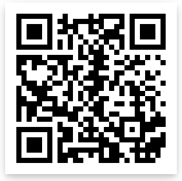
1. Click on Find my school
2. If you don't see Harford County Public Schools listed, click on My school isn't listed.
3. Click on Harford County Public Schools
4. Click on Sign in using Harford County Public Schools
5. Click on Log in with Active Directory https://bit.ly/2Ewck9k
6. Type in your username (username@student.hcps.org) and password

If have a Harford County Public Library card, go to next step to link your card to Sora.
If you don’t have a Harford County Public Library Card, follow these directions to apply:
Applying for a Harford County Public Library Card
Video Instructions
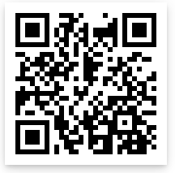
Directions for Parents:
1. Go to web address: https://hcplonline.org/policies.php#getacard
2. Under Digital Library card, click on Apply Online
3. Select your Home Library from dropdown menu and enter your postal code
4. Enter your child's information on the form https://bit.ly/2QqL7r3
5. Be sure to write down your pin# (This is usually the last four digits of your phone number)
6. Click on submit
7. Your child's digital library card number should be assigned. You will need to write that down in order to borrow books and for the next part of the lesson. (The next time you visit your local branch, you will be able to get your child's actual card, but in the meantime, your child can use their number to use digital resources.)
8. If you have any questions or technical difficulties in applying, please contact your local branch.
Turn over for directions to Link your Public Library card to Sora
Linking your Harford County Library Card to Sora
- Click the "hamburger" icon in the top right of
your screen. (Three horizontal lines)
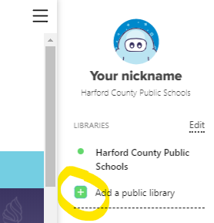
- Select the green plus to "Add a Public Library."

- Search for "Maryland's Digital Library"

- Click the green box "This is my library" below "Maryland's Digital Library"

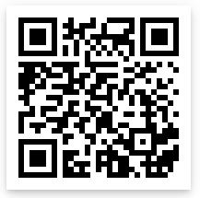
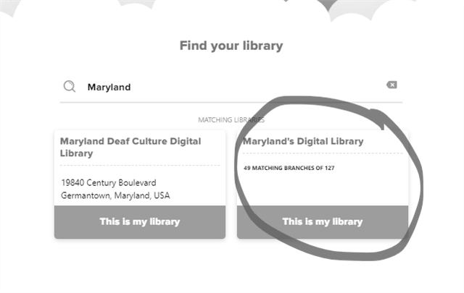
Video Instructions

https://bit.ly/34yWaGZ

Features of Sora and Searching for Books video:
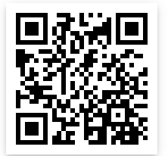
https://bit.ly/3jeMxS0

